Michelson interferometer
The Michelson interferometer is one of the most important and versatile instruments in optical technology. Michelson used this device to search for a preferred direction for the speed of light. The failure of this search is the cornerstone of Einstein’s theory of special relativity. The two largest examples of this instrument are located in Richland, Washington and Livingston, Louisiana. These devices have perpendicular arms each 4 km long and an optical system designed to detect interference fringe shifts much on the order of one part 10⁻²³ of a wavelength of light. This ambitious project is attempting to find supernova explosions, gamma-ray bursts and other exotic astrophysical phenomena that generate gravity waves that can cause tiny changes in the length of one arm relative to the other. (Website: http://www.ligo.caltech.edu).

This type of interference, that relies dividing the amplitude of light. This is used in numerous applications and instruments that include determination of optical flatness, all laser cavities, Fourier transform spectrometers, and more.

You will use the Michelson interferometer to observe the interference pattern of monochromatic light from a HeNe Laser and also from nearly monochromatic light from a sodium lamp.

- Introduction
An interferometer is generally defined as an optical instrument which produces interference patterns by the division of one beam of light into one or more parts. These parts travel different paths and are ultimately brought together to yield the interference effects. The resultant patterns depend of the optical paths traveled by the several beams. Consequently, the interferometer determines differences in optical paths.

- Learning goals
At the end of this lab you should be able to
- Use the Michelson Interferometer to observe interference pattern by division of amplitude
- Use a point source of light (a laser) to observe non-localized fringes displayed on a screen
- Measure the wavelength of laser by counting diffraction fringes
- Observe localized fringes formed by an extended source
- Determine the splitting in sodium D lines by measuring separation of “washout positions” in the spectra

- Procedures
IMPORTANT
- Before you start this lab, please remove any jewelry, watches, rings, etc. as reflecting surfaces will interfere with your measurements. Place those somewhere safe where you will find them when you are finished.
- Every timey your turn on the laser, you must turn laser warning sign on.
- Be careful of this laser beam. Do not stare into “direct” reflections off the lens or other surfaces.
- Do not touch or attempt to clean the mirrors.

Experimental setup
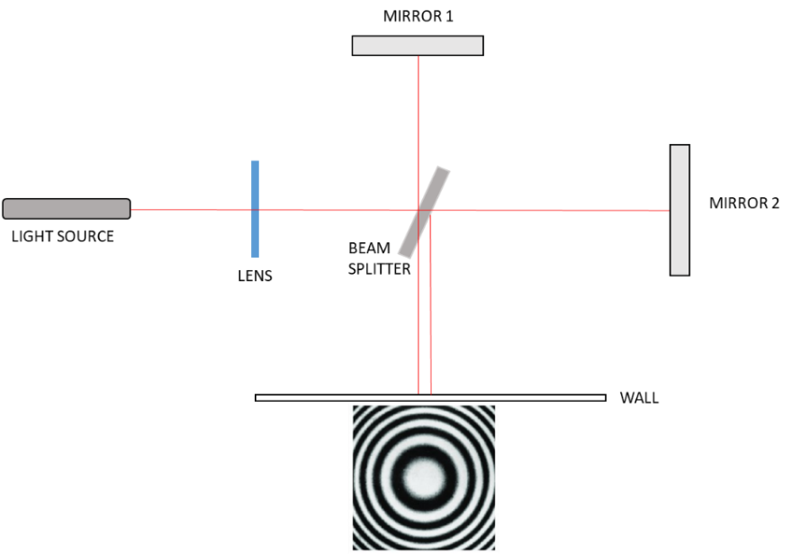

Simplified sketch of the experimental setup.

Lens. The lens is set in the path of the laser beam to expand the beam and have a more extended source. The lens effectively makes the laser appear as a point source at its focal length. This also helps to enlarge the interference pattern. It may be useful to use a second lens to help enlarge the pattern for best viewing, depending on the geometry of the setup. It can also be useful to view the laser beam go through the interferometer with no lenses in order to help achieve optimal instrument alignment.

Adjustment with HeNe
- One of the mirrors is moveable and uses two knobs to adjust the position.
  - The fine adjust knob is a long rotatable axis and (smaller wheel down below) MUST BE DISENGAGED before turning the gross adjust knob.
  - Pull up on the entire fine adjust axis to disengage.
  - Once the fine adjust is disengaged the gross adjustment knob can be moved freely.
  - Each smallest turn on the gross adjust wheel makes the moving mirror translate by 0.010mm, or 10 μm. That motion is about 20 times the wavelength of light, so you will try to read the mirror position to within a fraction of the smallest division.
  - When you re-engage the clutch so that the fine adjust knob moves the mirror, you will notice that it takes many turns to cover the slop in the gears and to engage the mirror motion. Once you start counting or want a position measurement, you must move only in one direction. Forward
  - If you wish to manually check how far the gross adjust knob moves the mirror you can look down from the top and view the a scale and pointer adjacent to the moving mirror, and observe what you must do to move the mirror one millimeter.
- Each of the mirrors also contains two angle adjustment knobs.
  - If the laser travels through the instrument with no lens in place, then you can observe that changing the tilt on the mirrors will make the primary beam reflection (as opposed to secondary or more) to overlap.
  - When placing a lens back in the instrument, you should observe the bullseye pattern (Airy Pattern is the math name).
  - We will try to make sure the system is in alignment before hand in order to display the “bullseye” HeNe pattern.
  - If you see an interference pattern, you may very carefully make small adjustments to the mirror angle tilt knobs to bring the bullseye pattern into view and keep it well centered.
- As you adjust the motion of the movable mirror with the fine adjust knob, you should observe fringe rings either moving inward, or outward.
- For the Michelson interferometer, the zeroth order fringe is at the 90º angle, while the maximum order is at the center. If you are moving the mirrors to reduce the path difference then fringes will disappear into the center. If you are moving to increase the path difference then new fringes will emanate from the center outward.
- The interferometer we are using has a zero path difference (equal arm length) at approximately 8.09 mm---reading both top down and on the gross adjust dial).
- You will want to start at a mirror position that is not near the zero path position.
- With the laser on, the instrument well aligned, mirror positioned appropriately, fine adjust knob engaged and all slop removed---you are ready to count fringes moving in or out. You may want to tape some paper to your screen and mark at the center of a fringe (not center of bullseye)---the middle of a stripe. You can use that as a reference to count fringes go by.
Data acquisition
Experiment 1. Determining the wavelength of a monochromatic light
- Once a good pattern of fringes has been obtained (with HeNe), fine adjust knob engaged, and slop removed from gears, take a reading of the mirror position. This is by looking top down at the scale next to the mirror and adding the markings from the gross adjust large knob For satisfactory precision, count at least one hundred fringes. Every time you move the translating mirror a half a wavelength (light travels there and back again) then a single fringe passes by your marking. The more fringes you count, the better your determination of wavelength.
- After counting them off, take a new reading of the mirror position.
- From the number of fringes passed over, Δn, and the distance traveled by the mirror, d , we may determine the wavelength of the monochromatic light by means of 2 d = λ Δn
- The translating mirror has mm markings along the translation arm of the interferometer. The gross adjust knob has smallest markings of one hundredth of a millimeter. I expect readings to one tenth of the smallest division. Note that this smallest division marking is still about twenty times the wavelength of typical visible light. Nonetheless the fine adjustment knob allows for easy accurate control at the level of single fringes (which indicates control at the half wavelength of light level)!
- When you move the mirror you must engage it and move in one direction only (to avoid any slop or backlash in gears). Therefore, you should always come from low to high when taking measurements.
  - This is generally true of any geared system
- You should note the significance of being near or far from the very special “equal path length condition”. You don’t want to pass through that special place on the interferometer since it will make it difficult to count fringes. As the position of moving mirror approaches the position of ZPL, you will observe that the periodicity of the circular interference fringes becomes larger, your bullseye will probably drift off center, and it will simply be impossible to count fringes—but this is why you read these notes first.
- If you count well, and are very careful, you may get a few percent measurement. Repeating is the equivalent of counting more fringes, and your average should improve your result.

Experiment 2. Measurement of the sodium doublet separation
The sodium doublet consists of two yellow spectral lines, having wavelengths of 5890 Å and 5896 Å. The 5890 Å is twice as intense as the 5896 Å line.
- The interferometer should be aligned. If you have done the laser measurements right before, it should be ready to go.
- You may remove the standing lens.
- This time, you will see the diffraction pattern looking directly in to light. This time, the pattern is a set of straight lines. The diffraction pattern is seen when your eye is focused at infinity. This is safe, it is not the laser.
- There are now two sets of fringe patterns formed, one for each line of the doublet. Loosen the carriage lock screw and move the carriage by hand and observe that the yellow fringes pass alternatively from a condition of high contrast to one of almost completely disappearance. This latter condition of occurs when one set of fringes is half way between the other set. Fix the carriage at one of the conditions of most complete disappearance by tightening the carriage lock screw and read the micrometer head. By turning the micrometer head, move to the next condition of most complete disappearance and read the head again. Repeat about 20 more times.
- You need to make sure that you do not confuse a “washout” position with the very special “equal path conditions” (for that condition the fringe is very broad, covers a large region and looks like washout….but it is not). If these get confused we can fix it later if you know how to interpret your data.
- This information can be used to determine the wavelength spacing between the two sodium lines Δλ (588.9950 nm and 589.5924nm in air). The average of the two wavelengths is 589.1941nm. In order to determine the wavelength spacing consider the following. At the first washout position (call this washout A), the interference condition for the center of the pattern for the longer wavelength is roughly
2d_{A}=m_{1A}λ₁
Now for the other wavelength (say the shorter) this same spacing corresponds to some different whole number of wavelengths plus a half wavelength for the shorter wavelength. So the distance is
2d_{A} =(m_{2A}+1/2)λ₂ .
The two different values for m's are both integers so the two differ from each other by some integer value n. That is since both are integers then m_{1A}+n=m_{2A} for some integer n. The path length for a particular washout position is then
2d_{A}=m_{1A}λ₁=(m_{1A}+n+1/2)λ₂ .
- Now if d is increased to the next washout condition then the fringe number for the shorter wavelength has increased by one more fringe than for the longer wavelength. (As the path difference is changed then more of the shorter wave fringes pass by than for the longer, it is one more by the next washout position). So the new condition is
2d_{B}= m_{1B}λ₁=(m_{1B}+n+3/2)λ₂.
You can use these conditions to obtain an approximate expression for Δλ in terms of measurements. Note λ₁λ₂ ≅ (λ_{ave})² since the two wavelengths are close together.

The Michelson Interferometer

Note several adjustments that you can make with this instrument as demonstrated. There is a height adjustment knob. Note the mirror translation scheme has two knobs, a fine tuning knob and gross adjustment. The fine tuning knob may be used when the gear is in contact with the gear for the gross adjustment knob. Turn the gross adjustment knob only when the fine tuning knob is disengaged. Lift up on the fine adjust knob arm to disengage this arm. The (an) instrument documentation manual (long) is posted for your use. You may also want to browse either the internet or any standard optics text for discussion of the Michelson interferometer. A Michelson interferometer is the heart of many high precision instruments such as Fourier Transform Interferometers, and gravity wave detection (sort of). Processes that follow from division of amplitude (beam splitting) interference allow for high precision measurements of lengths, wavelength, and development of high quality optical cavities and high precision analysis of optical surfaces.
The translating mirror has mm markings along the translation arm of the interferometer. The gross adjust knob has smallest markings of one hundredth of a millimeter. I expect readings to one tenth of the smallest division. Note that this smallest division marking is still about twenty times the wavelength of typical visible light. Nonetheless the fine adjustment knob allows for easy accurate control at the level of single fringes (which indicates control at the half wavelength of light level)!
I have placed a lens in the HeNe laser path to the interferometer to expand the beam and give a more extended source. You should use this setup to become familiar with the instrument. You may adjust the position of the free standing lens, the position of the interferometer and any knobs on the interferometer. You are responsible for being able to perform a quick and accurate setup.

DO NOT TOUCH OR ATTEMPT TO CLEAN THE MIRRORS.

TASKS
A.) Set up the Michelson Interferometer so that the bright HeNe laser passes through the free standing lens and into the interferometer. After careful alignment you should see a "bullseye" interference pattern on the wall. Each of you should be able to set up the instrument in a few minutes. Be very careful using the lenses and other optics with this laser. Remove jewelry and make sure you know where any stray rays are directed. With the interference pattern set up count fringes vs. mirror displacement to determine the wavelength of the HeNe laser. Make sure you count at least a few hundred fringes (think about precision). When you move the dial you must engage it and move in one direction only (to avoid any slop or backlash in gears). In your report make sure you discuss any relevant uncertainties in your readings and results. Note that the mirror movement has "play" or "slop" in the gear mechanisms, so you should always come from low to high when taking measurements. You should note the significance of being near or far from the very special “equal path length condition”. You don’t want to pass through that special place on the interferometer since it will make it difficult to count fringes.

In the HeNe Laser path I use an external lens next to the laser to make the beam diverge. This helps to enlarge the interference pattern. The lens on the interferometer may or may not be used in addition.

B.) Use the sodium lamp to view a pattern directly (you must look at viewing into the interferometer into the light (sodium light---not laser). I have had success shining the yellow light on paper as an extended source and then into the interferometer (carefully directed). If you used the laser to carefully align the interferometer first, then you should see the sodium fringe pattern appear immediately. The pattern is viewed while your eye is focused at infinity. You may move the interferometer and you do not need the free standing lens—place the white paper screen so that it reflects sodium light into the front of the interferometer. Measure the distance that the travelling arm must travel between each of several consecutive wash-out positions (lowest contrast pattern positions). These are the positions where the interference pattern is least distinct. You need several such readings (maybe 20 or so) and you need to make sure that you do not confuse a washout position with the very special “equal path conditions” (for that condition the fringe is very broad, covers a large region and looks like washout….but it is not). If these get confused we can fix it later—your data will tell the story of what happened if you know how to read it. You may have viewed that equal path length position in part A—so you know about it. Don’t get confused on counting these nearly equally spaced washout conditions.

These washouts occur due to two different overlapping interference bullseye patters. The patterns come from two different closely spaced resonant emission lines (different colors) in sodium. When the bright rings from one pattern lie halfway between the bright rings of the other pattern, the entire pattern becomes indistinct (washouts). You will measure how far to move the adjustable mirror between washouts (plot mirror position vs. washout number).

This information can be used to determine the wavelength spacing between the two sodium lines Δλ (588.9950 nm and 589.5924nm in air). The average of the two wavelengths is 589.1941nm. In order to determine the wavelength spacing consider the following. At the first washout position (call this washout A), the interference condition for the center of the pattern for the longer wavelength is roughly 2d_{A}=m_{1A}λ₁ . Now for the other wavelength (say the shorter) this same spacing corresponds to some different whole number of wavelengths plus a half wavelength for the shorter wavelength. So the distance 2d_{A} =(m_{2A}+1/2 )λ₂ . The two different values for m's are both integers so the two differ from each other by some integer value n. That is since both are integers then m_{1A}+n=m_{2A} for some integer n. The path length for a particular washout position is then 2d_{A}=m_{1A}λ₁=(m_{1A}+n+1/2 )λ₂ . The "A" subscript refers to this particular washout at this path difference.

Now if d is increased to the next washout condition then the fringe number for the shorter wavelength has increased by one more fringe than for the longer wavelength. (As the path difference is changed then more of the shorter wave fringes pass by than for the longer, it is one more by the next washout position).

So the new condition is 2d_{B}= m_{1B}λ₁=(m_{1B}+n+3/2)λ₂. You can use these conditions to obtain an approximate expression for Δλ in terms of measurements. Note λ₁λ₂≅(λ_{ave})² since the two wavelengths are close together. We will go over the end result. Compare your measured separation of the two sodium lines to the known. Discuss uncertainties in your measurements.

C.) If there is time your instructor may demonstrate white light fringes to you.

D) There are many other things that can be done with this type of setup. Different laser (see me), index of air, other…..The Michelson interferometer is a versatile instrument.

